**SIMPLIFYING ALGEBRAIC FRACTIONS**

* *Factorize numerator & denominator then cancel common factors*

**DO NOT make this COMMON MISTAKE:**

**Ex 1**

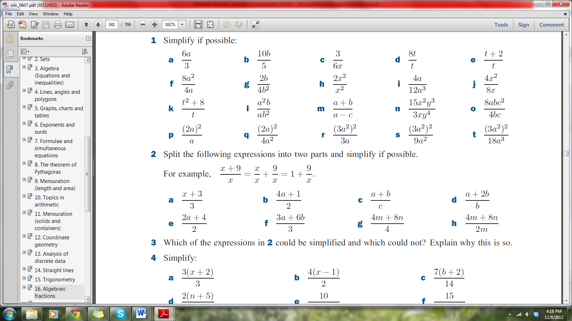

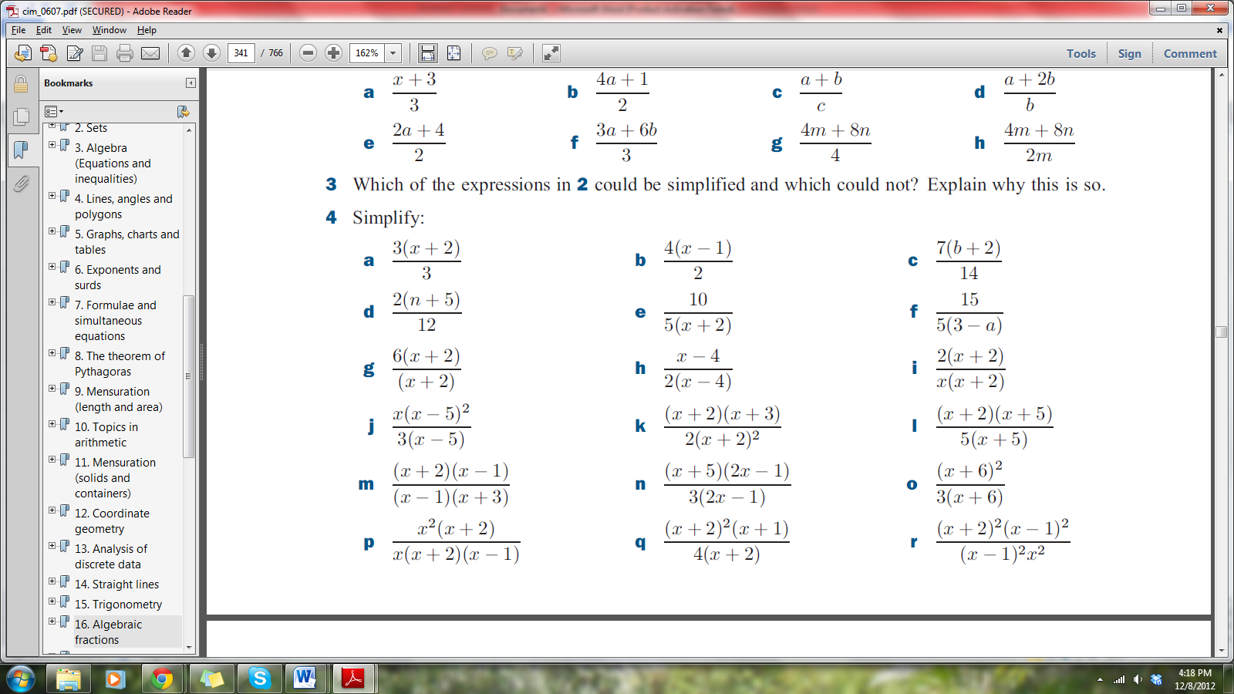

Ex 2

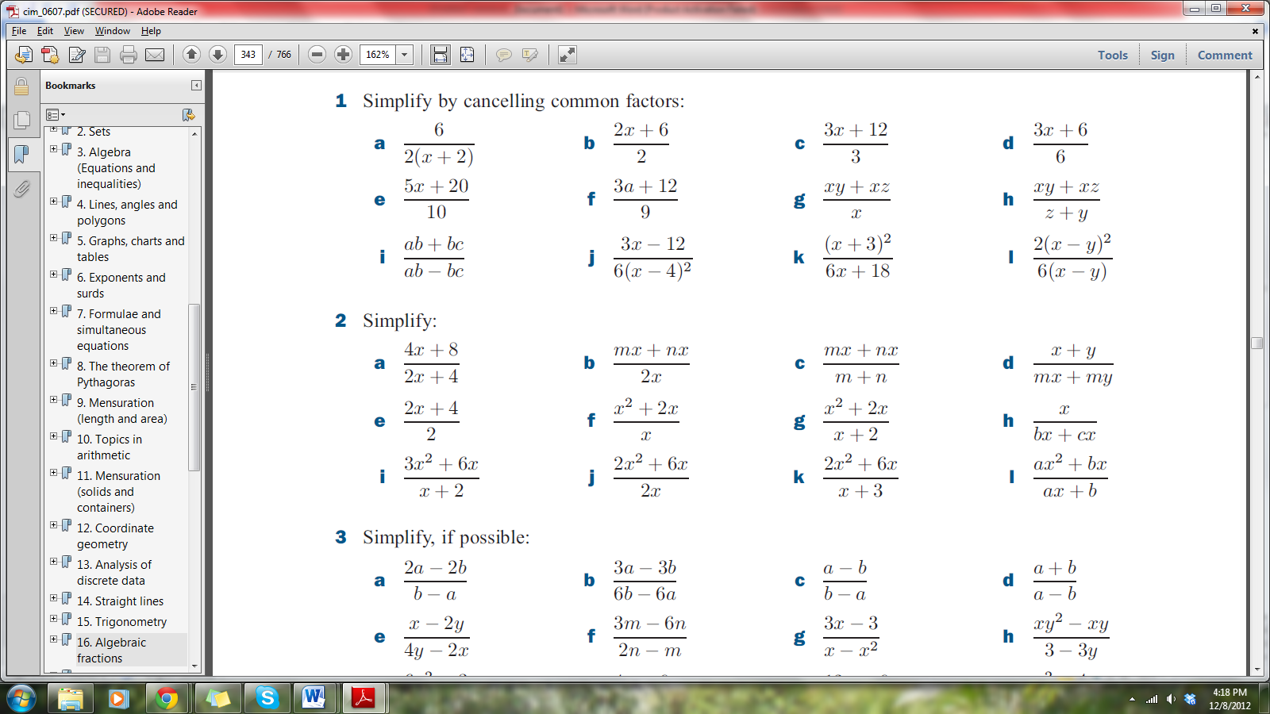

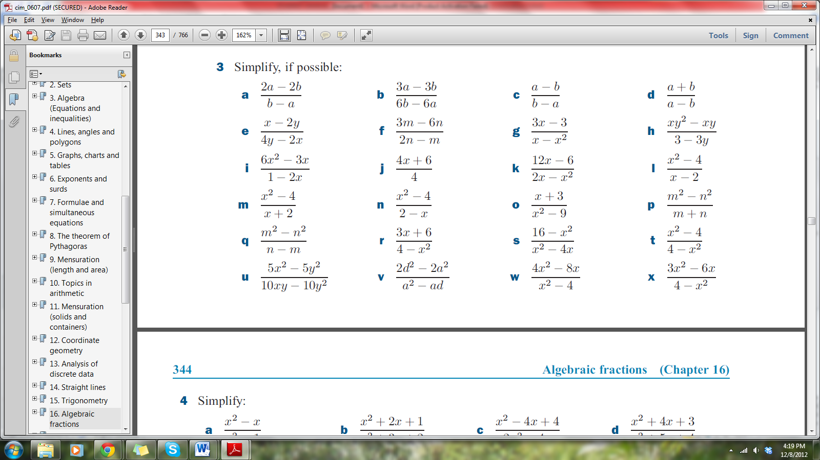

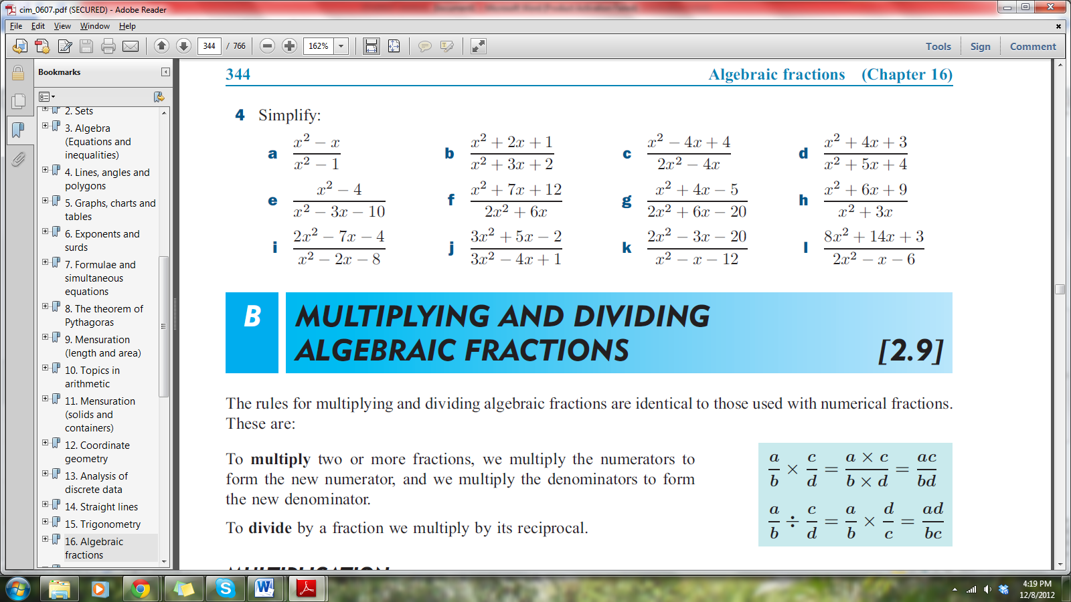

**OPERATIONS WITH ALGEBRAIC FRACTIONS**

* *When adding /subtracting find LCM, then adjust numerators as is done for numeric fractions*
* *When multiplying, or when dividing( reciprocate then multiply), cancel any numerator with any denominator then simplify*

Ex 1

Find the LCM and HCF of the following:



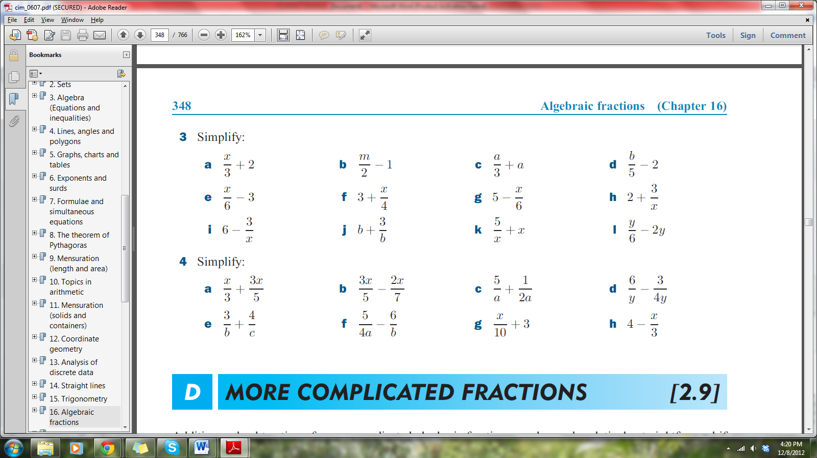Ex 2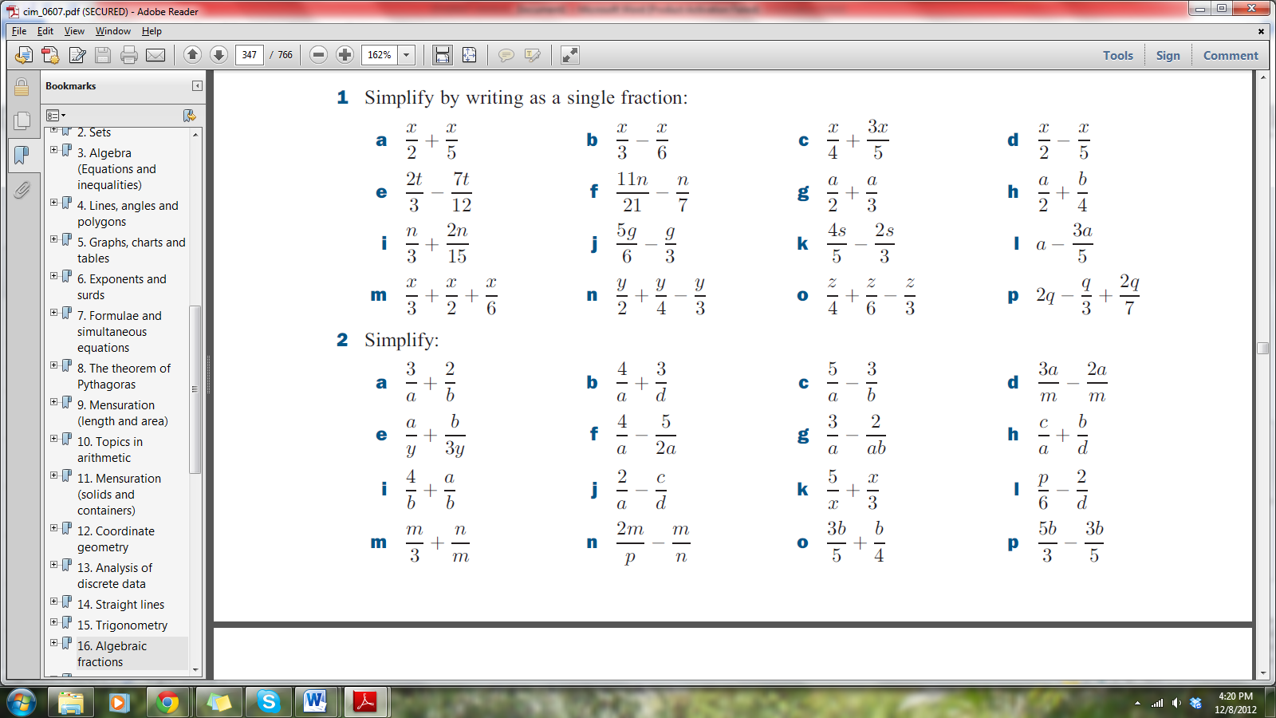

Ex 3

